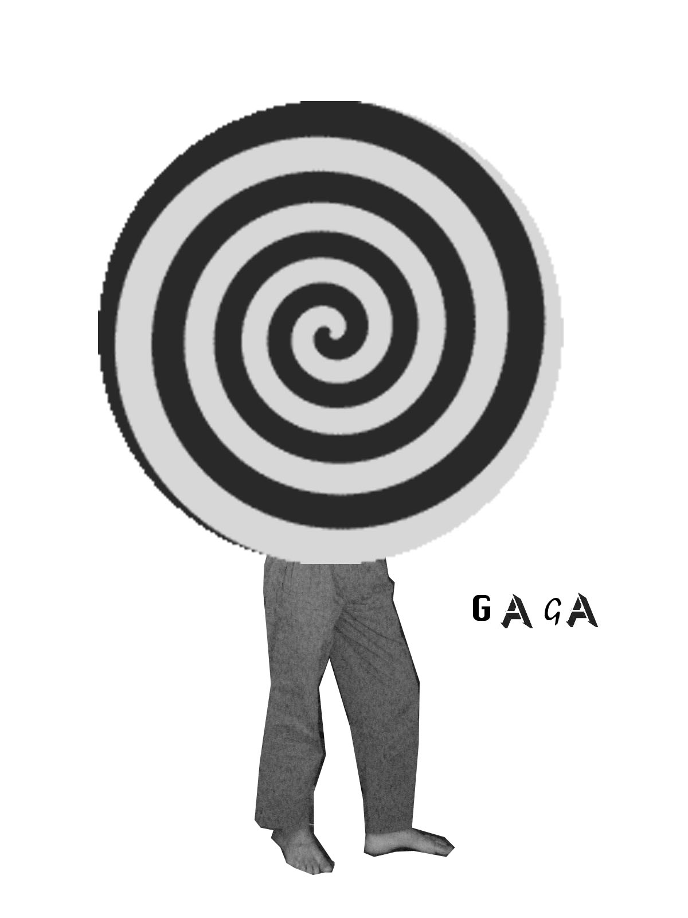

PRESS RELEASE / EXHIBITION GUIDE
Cantos Revolucionarios del Corazón
Works by Guillermo Santamarina at Gaga
September 10 - November 7, 2008.
www.houseofgaga.com

After 30 years of professional experience developed in more than three hundred exhibitions, Mexican curator Guillermo Santamarina presents his second solo show, reappearing to the world as an (emerging?) artist at Gaga.

The exhibition –chaotically- organized with a couple of intervened music instruments, audiovisuals, an installation emphatically absorbed by museographic try-ons, and photographic collages, highlights the false expectations of the contemporary artist, the homage to the square and to painting, but most of all, the homage to pop culture located in the limit of absolute vulgarity and the sublime. All of this appointing to blurred expectations or, as Santamarina mentions, exploring the possibilities of salt sculpture tasks”.

Even the artist’s announcement of a total freedom march, his work moves through a multidimensional kind of filter: Guillermo’s fondness about the past. His feelings towards moments and icons from Western Modern Art History, movie decoration, Museography, Music and indiscriminate sound, Vinyl records, or his personal history that comes out in imaginary alphabets and color codes only known to their creator. Finally, the artist juxtaposes, cancels, breaks up or obliterates with video projections, found stickers or duct tape.

Another way to enter this exhibition is recalling the works that were cast away. In the past, or as a possibility, Homage to Jean Genet, three green apples, a Debussy record, fresh lavender and a tin lamb doll; Neu! World Order, six low-budget copy prints from Neu!’s vinyl; and Dormimundo, a carpet with a well-known Mexican mattress shop logo. Then there is the first idea for the exhibition: a waiting room, a casting room and a filming studio, a study on the relation between youth and music, and the way it is perceived by society, the News Divine, Ten or more (Possible) Reasons for the Sadness of Thought.

Repression as a creative force, the abolition of the revolutionary chant, the search for new plastic principles.

Project in collaboration with Maurcio Marcin.

Guillermo Santamarina (Mexico 1957). Since 1980 has collaborated in the emergence, education, and projection processes of at least 3 generations of visual and sound artists. Organizer of more than 200 exhibitions, set in institutional and independent frames, as well as various Site-specific projects, Music and Performance International festivals, and Art theory encounters. Founder member and Content Advisor for SITAC (Contemporary Art Theory International Symposium). Commissioner for the Mexican representation at various World-renowned exhibitions (Johannesburg, Istanbul, Sao Paulo, etc.). Teaches Art History and Contemporary Theory subjects at different universities and Art schools. Former Director of Ex Teresa Arte Actual (INBA), from 1998 to 2004. Currently in charge of the programs of Museo Experimental El Eco(UNAM).

Special thanks to: David Miranda, Begoña Inchaurrandieta, Enrique Minjares, Rogelio Sikander, Francisco Outon y Miguel Marcin.

